Rule Based AI Parser
By: Joshua Smith
4/21/26
CSCI 311
Professor: Dr. Sree Malladi

Information

Language: Prolog
Compiler Used: https://www.onlinegdb.com/online_prolog_compiler
Repo Link: https://github.com/father4000/CSCI311-Project-Auto-Parser

Index
Project Overview: 3 -- 4
Code: 5 -- 10
Screenshots: 11 -- 21

Introduction:
For my project I chose to make an AI rule based natural language parser. I wanted this project to take a basic sentence and break it down into its components such as verb and noun. One reason for going this route is because we covered things such as parsers, grammar, and BNF. The other reason was this intrigued me as an idea because it would steer me toward languages I have never used and hopefully let me play with how early versions of AI were built and used. It seemed like a good opportunity to test new waters while pertaining to class material.

Language:
Although there are a great many languages that would have done well for this project one was the natural choice as my professor said. Prolog would be that natural choice. The language was latterly created for ruled based AI. Not to mention its handling of grammar as a built-in feature being a major boon for tis project. It also was a strong choice for its natural language handling ability. Such features made this language choice almost a non-choice.

Syntax:
Prolog is very different from any language I have used in the past barring database quiring, and this made its syntax a little problematic at first. Some of the big take aways is that Prolog uses terms. These are facts, rules, and relationships that interact very similarly to what a database would do. There are atoms, numbers, variables, compound terms, and data structures like what I am used to seeing but with a great deal more restrictions. Yet they are freer too. An atom is a constant that must be lower case and can be a number or string-like structure. Numbers are limited to integers, floating point, and rational in some versions of Prolog. On the data structure side, we have lists, pairs, and strings. Compared to things like C++ these options are crazy limited in verity but are still powerful. Variables start with an uppercase letter always. The entire language operates more like a procedural language than an object oriented one but is considered a logic language. Logic means its less about how and more about rules and finding answers.

Strengths and Weaknesses:
Prolog’s tools for rules and the fact that it is a logic language allowed me to do so much work in an insanely small number of lines. I could not believe that my code would be sub 150 lines with comments removed. The built-in features for my grammar rules and how Prolog handles loops made for such a small main body. I built the entire program in blocks almost. Mentally they remind me of functions from object oriented programming but far easier to move around in. For a weakness I found outputting to the console to be one of the most tedious things I have done in a long time. Making it output the broken down sentences in general was not too hard. Making it look like a parse tree and follow through reliably took me as long as the rest of the program. I will also add that troubleshooting could not be done in the ways I am used to. I did a lot of change code and see what it puts out on my project. I also had a very difficult time coming up with input error handling. I neve did figure out how to make the period at the end not required.

Program Summary:
My program lists 20 precompiled short and simple sentences. They are done in such a way as to leave to code as simple as possible. The sentences are also short and simple in structure to keep the rules simple. You pick one of the sentences and the program will break it down based on the rules I have given it. It then outputs the breakdown of verb and noun in a parse tree that mostly hits the looks. Option 20 is specifically designed to fail parsing. The program will loop till you pick 0 to quit. The program has input checking for valid option selection, but the program will fail if the option is not ended with a period.

Conclusion:
Overall using Prolog in this project was a fun endeavor. Although some things seemed overly difficult to do and the lack of freedom in telling the program how to do everything was frustrating at times. I cannot say I would not use the language again. The simplicity of the language and the power of its features are not lost on me. It still blows my mind at how simple the code is overall “barring the output” and how little coding it actually took to do this project. The syntax was very different from things I have used in the past but also did not feel overwhelming. A perk if the languages logic roots.

Code
/*
Program Name: Rule Based AI Parser
Author: Joshua Smith
Date: 3/30/26
Purpose: Takes a selection of 20 sentences the user can pick from and breaks
them down into components such as verb and noun using grammer rules. Showen as
a parse tree.

Note: For use with https://www.onlinegdb.com/online_prolog_compiler
I had different behavior from different compilers. Some would not compile at all.

*/

:- initialization(main).

% Sentences
% Formated to make life easier. Number 20 is purposly invalid.

sentenceDB(1, [the, josh, sees, a, groundhog]).
sentenceDB(2, [josh, dislikes, the, groundhog]).
sentenceDB(3, [josh, chases, the, groundhog]).
sentenceDB(4, [josh, sees , a, dog]).
sentenceDB(5, [josh, likes, the, dog]).
sentenceDB(6, [the, dog, sees, the, josh]).
sentenceDB(7, [the, dog, likes, josh]).
sentenceDB(8, [the, dog, chases, josh]).
sentenceDB(9, [the, groundhog, sees, the, dog]).
sentenceDB(10, [the, dog, sees, the, groundhog]).
sentenceDB(11, [the, groundhog, dislikes, a, dog]).
sentenceDB(12, [the, dog, chases, the, groundhog]).
sentenceDB(13, [josh, chases, the, dog]).
sentenceDB(14, [a, groundhog, sees, a, josh]).
sentenceDB(15, [the, groundhog, dislikes, josh]).
sentenceDB(16, [dog, sees, groundhog]).
sentenceDB(17, [dog, chases, groundhog]).
sentenceDB(18, [groundhog, dislikes, dog]).
sentenceDB(19, [the, dog, dislikes, a, groundhog]).
sentenceDB(20, [a, groundhog, dislikes, the, a]).

% Outputs the sentence choices as a list.
showSentences :-
forall(sentenceDB(N, S),
(write(N), write(': '), write(S), nl)
).

% Main loop.

% Starting output.
main :-
nl,
write(' Rule Based AI Sentence Parser'), nl,
write('-----------------------------------'), nl,
loop.

% Menu loop.
loop :-
% Main menu output.
nl,
write('Available Sentences:'), nl,
showSentences,
write('0: Exit'), nl, nl,

write('Select a sentence (1-20) or 0 to quit. Put a . on the end. Ex = 1.'), nl,
% Getting choice. Will error if not ending with . or invalid input is used.
read(Choice),

% ( Condition -> Then ; Else ) If-then-else referance.
(Choice = 0
-> write('Have a great day!'), nl,
halt
; handleChoice(Choice),
loop
).% End of choice.

% Shows selected sentence. If parsed successful outputs tree otherwise error.
handleChoice(Choice) :-
(sentenceDB(Choice, Sentence)
-> nl,
write('Selected Sentence: '), write(Sentence), nl, nl,
(phrase(sentence(ParseTree), Sentence)
-> write('Parse successful!'), nl, nl,
write('Parse Tree:'), nl,
printTree(ParseTree, '', true)
; write('Parse failed.'), nl
)
; write('Invalid selection. Try again.'), nl
).% End of handle choice.

/* Grammer rules
A sentence is a noun phrase followed by a verb phrase.
A noun phrase is a determiner followed by a noun.
A noun phrase can also just me a noun.
A verb_phrase is a verb followed by a noun phrase.
*/

sentence(sentence(NP, VP)) --> nounPhrase(NP), verbPhrase(VP).
nounPhrase(noun(Det, N)) --> determiner(Det), noun(N).
nounPhrase(noun(N)) --> noun(N).
verbPhrase(verb(V, NP)) --> verb(V), nounPhrase(NP).

determiner(det(the)) --> [the].
determiner(det(a)) --> [a].
noun(noun(josh)) --> [josh].
noun(noun(dog)) --> [dog].
noun(noun(groundhog)) --> [groundhog].
verb(verb(chases)) --> [chases].
verb(verb(sees)) --> [sees].
verb(verb(likes)) --> [likes].
verb(verb(dislikes)) -->[dislikes].

/* ASCII tree printing
Have to capitalize first leter to make a variable.
Lots of comments as this was super annoying to do.
Most time out of entire program by far.
Used many resources to get this annoying thing to work right.
*/

% Base case: Just prints word with current indention.
printTree(Node, Prefix, IsLast) :-
atomic(Node), !, % If Node is a word.
( IsLast -> Branch = '|>> ' ; Branch = '|- ' ), % Choose branch symbol.
write(Prefix), write(Branch), writeln(Node). % Print with prefix.

% Recursive case: Print with increasing indention by 3 spaces.
printTree(Node, Prefix, IsLast) :-
Node =.. [Label | Children], % Breaks Node into Label and Children.
( IsLast -> Branch = '|>> ' ; Branch = '|- ' ), % Choose branch symbol.
write(Prefix), write(Branch), writeln(Label), % Print current node.

% Sets new prefix for children.
( IsLast -> string_concat(Prefix, ' ', NewPrefix) % Last child.
; string_concat(Prefix, '| ', NewPrefix) % Not last.
),
printChildren(Children, NewPrefix). % Print children recursively.

% Print a list of children
printChildren([], _). % No children = done.
printChildren([C], Prefix) :- % Last child.
printTree(C, Prefix, true).
printChildren([C|Cs], Prefix) :- % Other children.
printTree(C, Prefix, false),
printChildren(Cs, Prefix).
Screenshots
Note: Option 16 is missing due to a typo in code. Fixed for last submission and last screenshot.
Input error out of range.
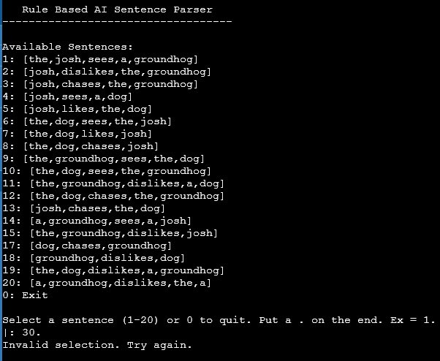

Input error not a number.


Option 1
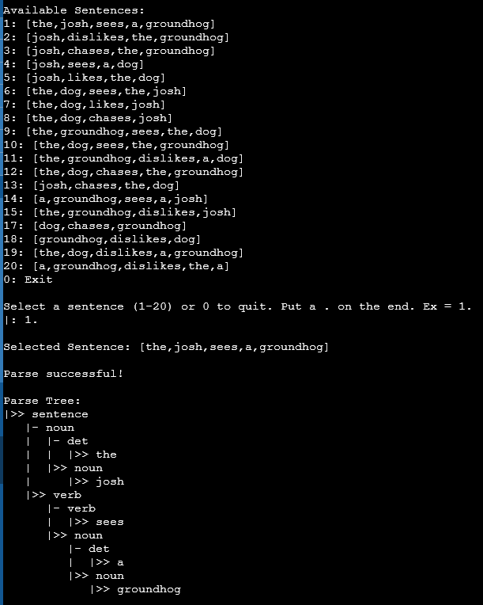

Option 2
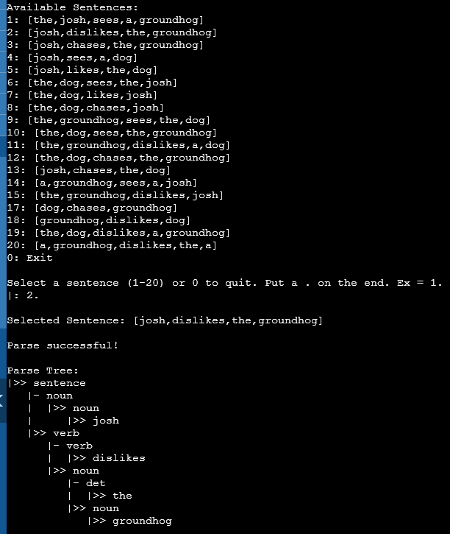

Option 3
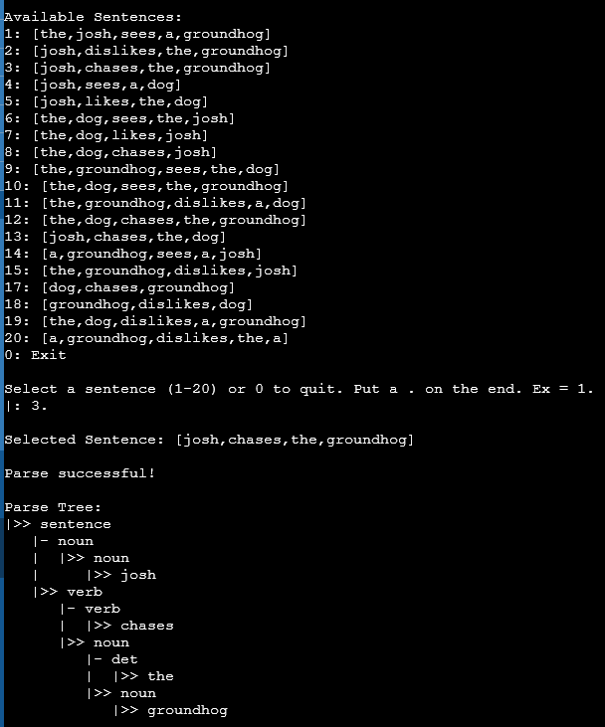

Option 4
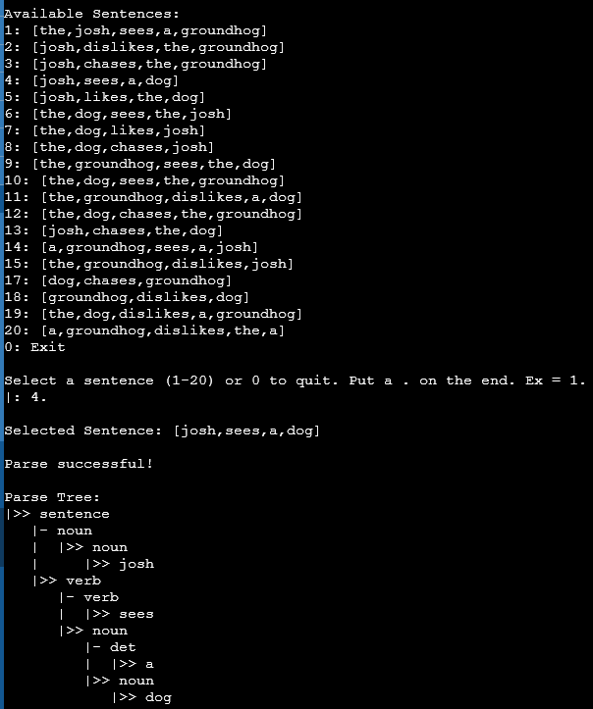

Option 5
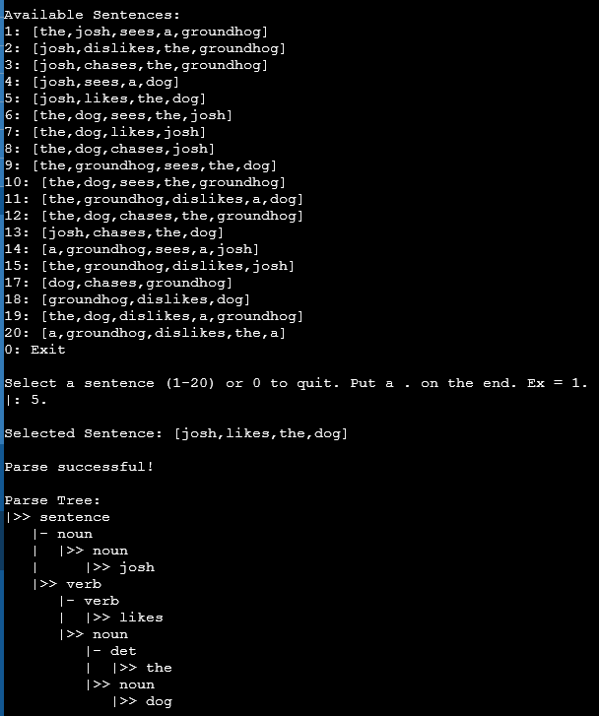

Option 15
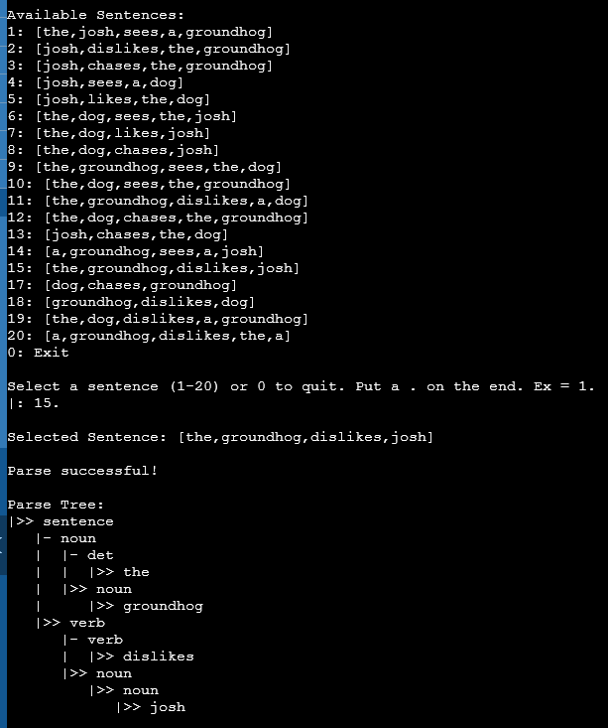

Option 18
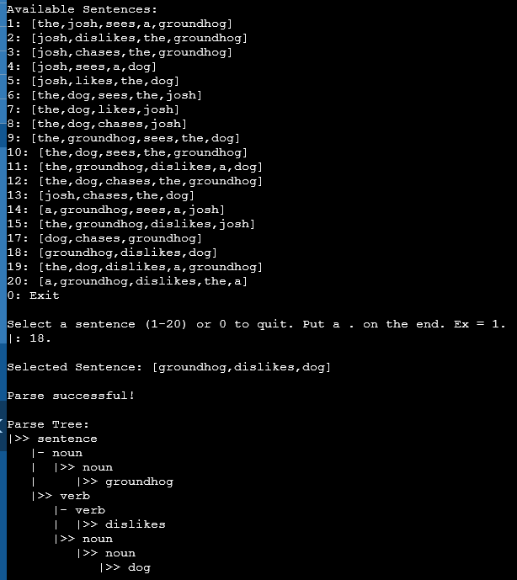

Exit
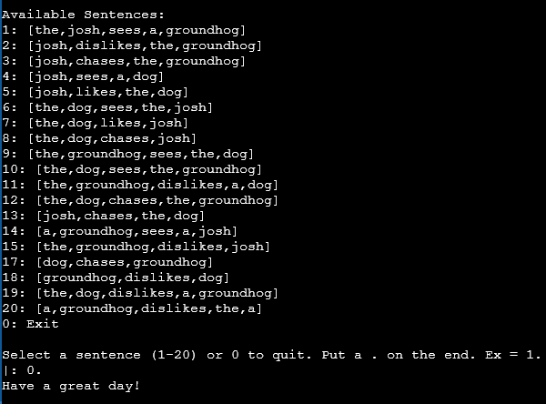

Option 16 after correcting typo.
